

Hattie Larlham Email Signature Guidelines 2022
The following email signature guidelines are to be followed by every Hattie Larlham employee.
This document serves as a step-by-step guide on how to setup your required email signature.

- Open Microsoft Outlook. Click on “New Email”.

- Click on “Signature” button (pen and paper icon towards the middle).

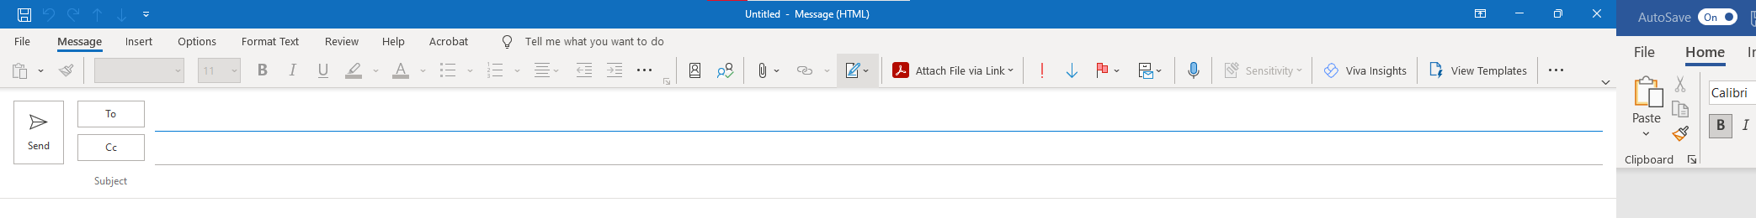

Once you click “Signature” select “Signatures…” from the dropdown.

- Now click “New”.
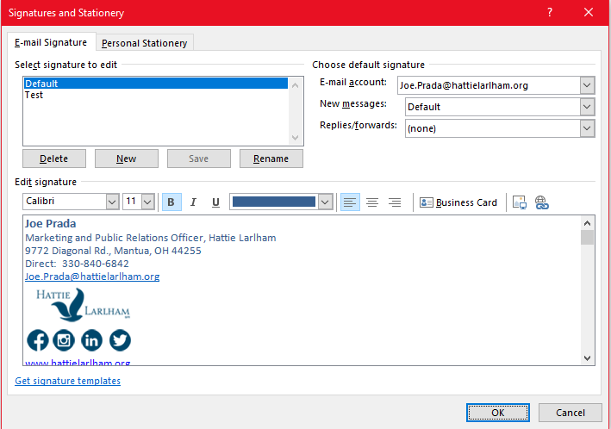
- Type “Default NEW” as your signature name.
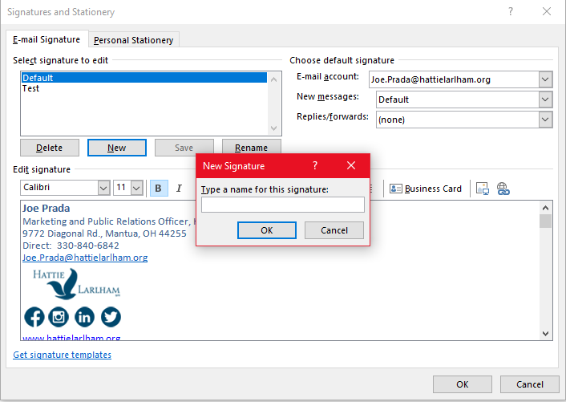

- Before closing out of this box…go to “New messages:” and make sure to select “Default NEW”. You will want to do the same thing for the field directly below, “Replies/forwards:”. Once you complete these steps you can hit “OK”.
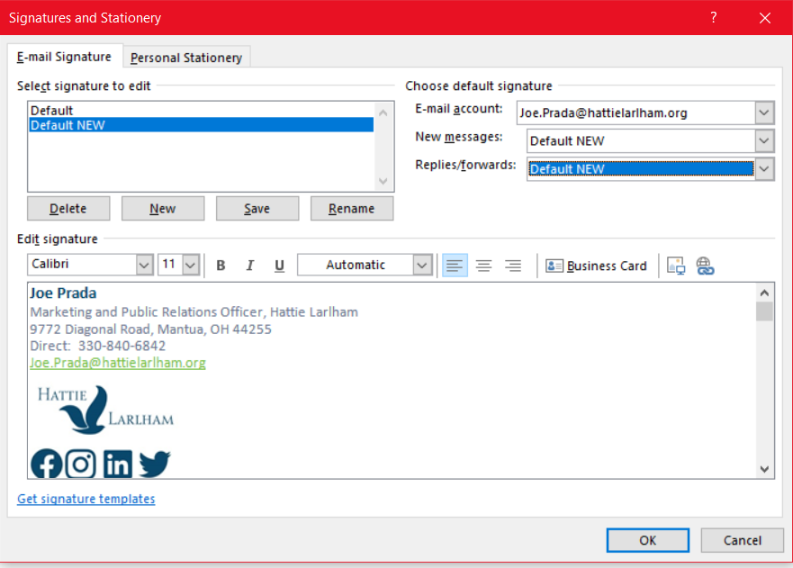
- Now select and copy (right-click once selected and hit “Copy”) the following text and graphics in this Word document below in the red square. Make sure to not select the red outline. Only complete Step 6 on your provided laptop/desktop computer. Do not copy and paste via the Mobile Outlook App.

Joe Prada
Marketing and Public Relations Officer, Hattie Larlham
9772 Diagonal Road, Mantua, OH 44255
Direct: 330-840-6842
Joe.Prada@hattielarlham.org


#BrighterTogether
hattielarlham.org

- Now go to your “Edit signature” field in Microsoft Outlook. Right-click in the white box and select “Paste Options: Keep Source Formatting” (icon should appear as clipboard and paintbrush).

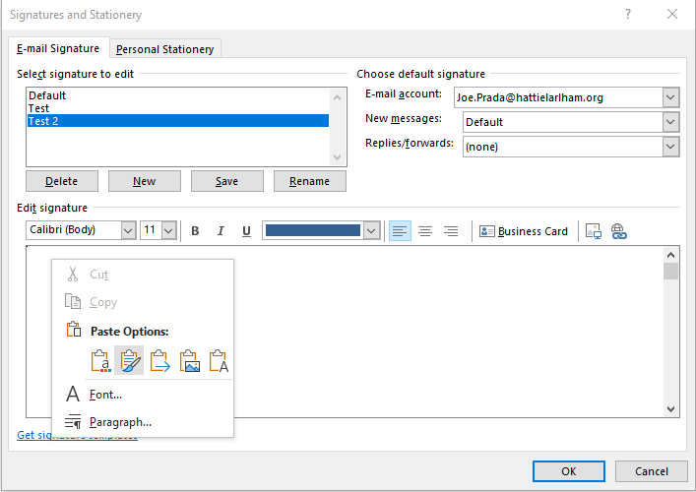
The signature copy from the Word document should now appear in your “Edit signature” field.
- Now you will want to edit all the contact information to your appropriate information. Make the edits to the name, title, address, and phone lines without editing the font format. Then edit the email by selecting the email line and clicking the hyperlink button (Internet sphere with infinity icon).
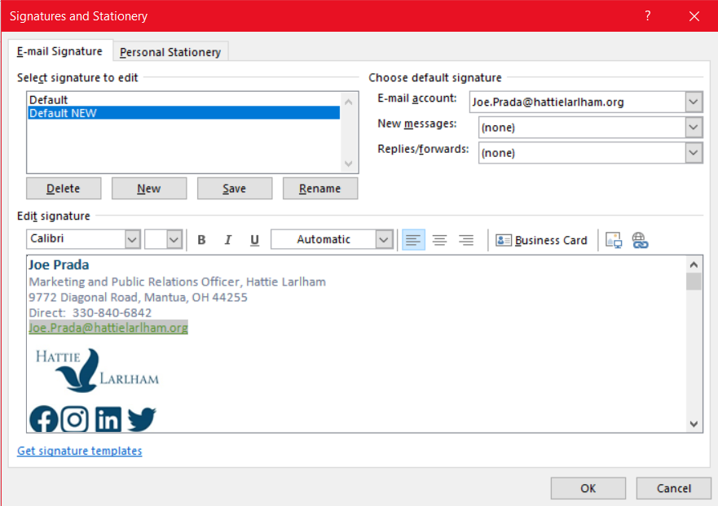
You edit your name in the “Text to display:” field first. Then make sure to edit the “E-mail address:” field to your name as well. Note: Make sure you do not delete the “mailto:”. Once complete hit “OK”.
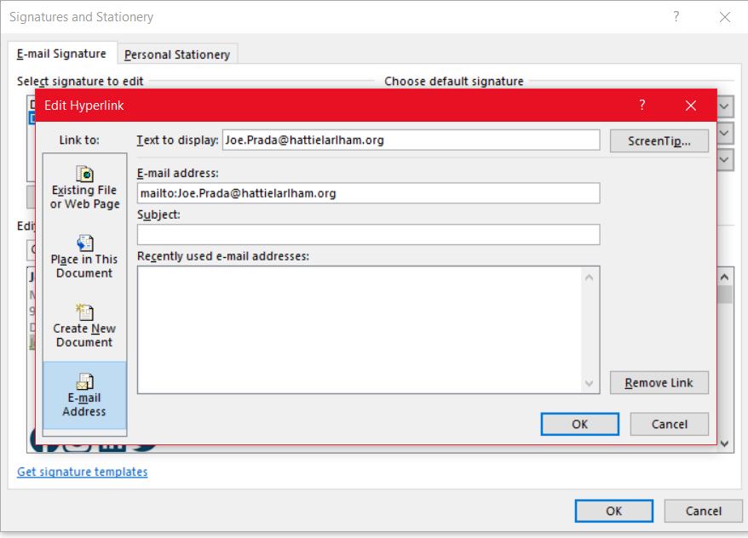
Make sure to hit “Save” once the signature is pasted and updated to your contact information. You can also refer to document “Email Signature Template 2022” for additional notes on formatting.
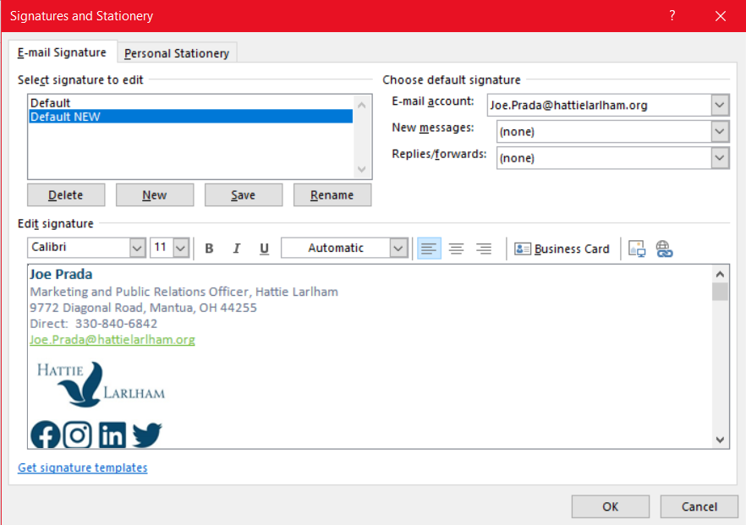
When you select “New Email” or “Reply” to an email your email draft should automatically generate this new signature. If you are not seeing the following (screen shot below), please contact I.T. Department.
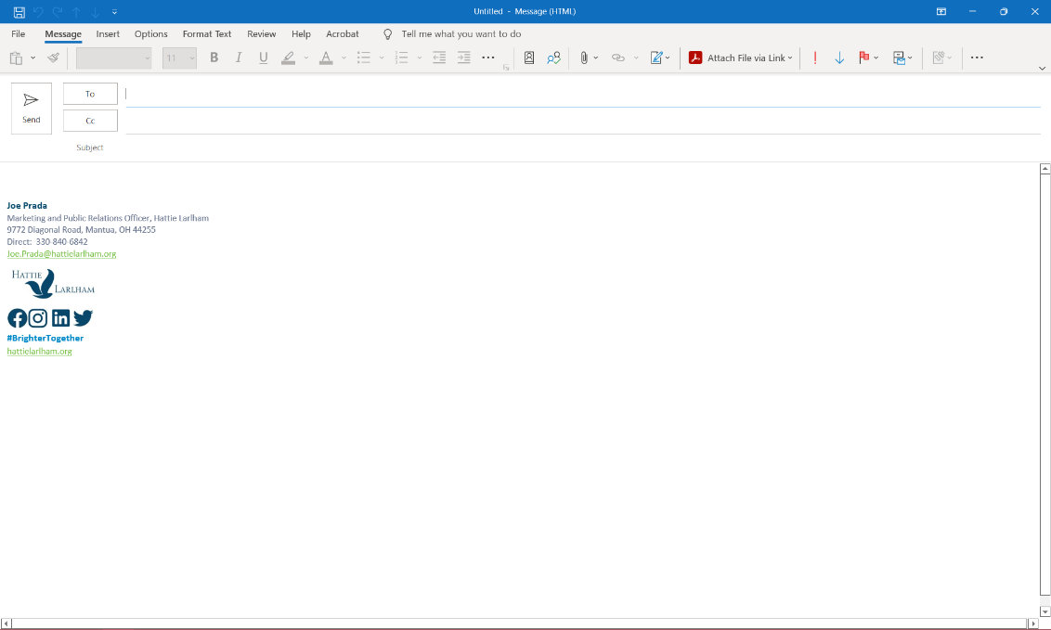
You’re finished setting up your signature on your desktop! Now it’s time to setup your signature on the Outlook App on your mobile device. You do not need to complete the following steps if you do not send emails via your mobile device.
- From your desktop computer, using Outlook, send an email to yourself including your newly setup signature.

- Now go to your mobile device, using Outlook App, open the email you just sent to yourself. Select and “Copy” lines 1 -5 of your signature (see screenshot below). You do not want to copy the logo or anything below. The Outlook App does not have the capability to include HTML imagery at this time.

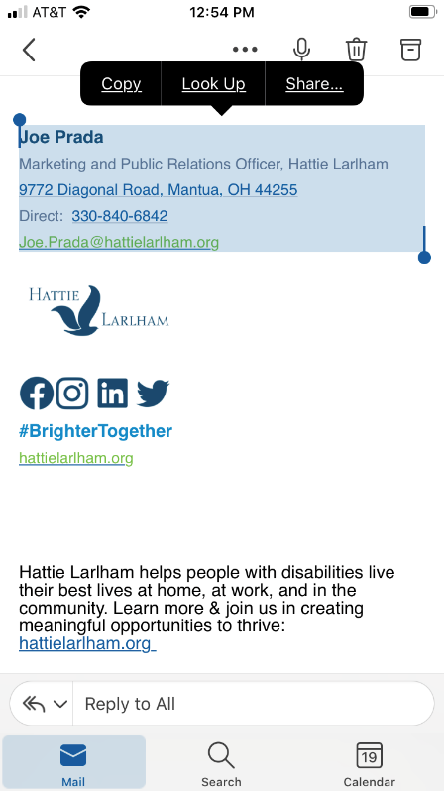
- Go back to the main menu of your Outlook App on your mobile device. At the main menu select the circle icon associated with your account.
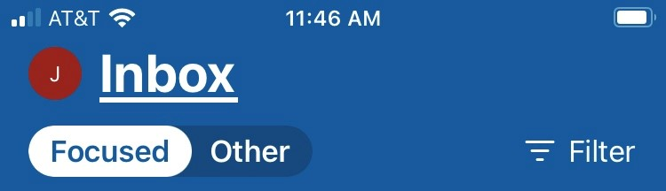

- Now select “Settings” (gear icon) in the bottom left corner.
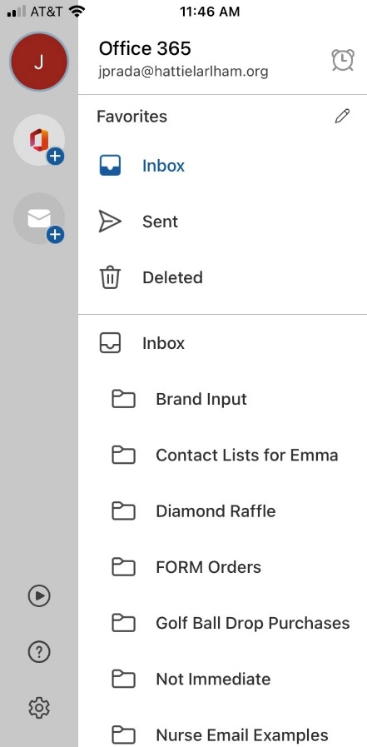

- Select “Signature”.

- You will want to “Paste” your copied signature in the “Signature” field box. Once pasted, just click the arrow pointing to the left in the upper left-hand corner.
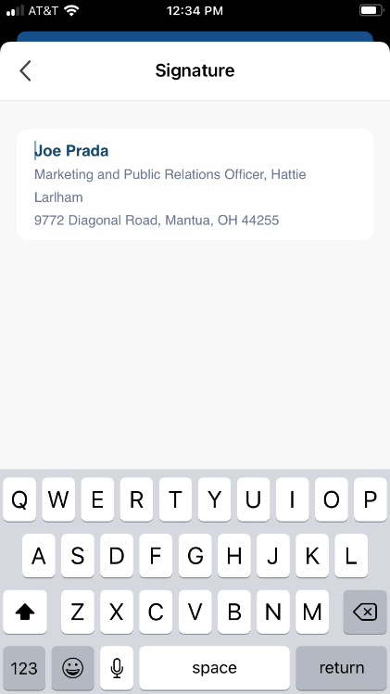
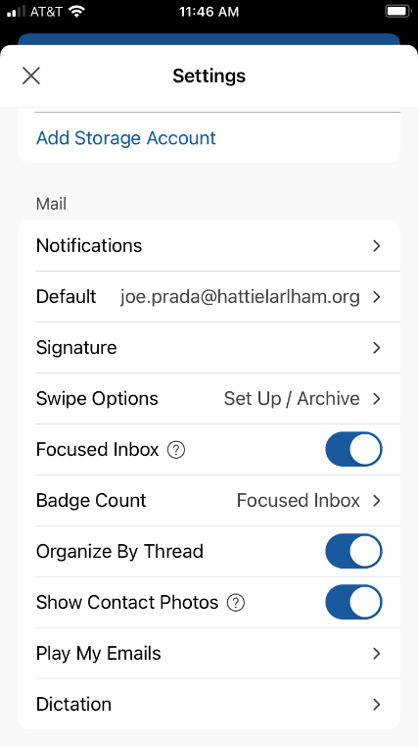
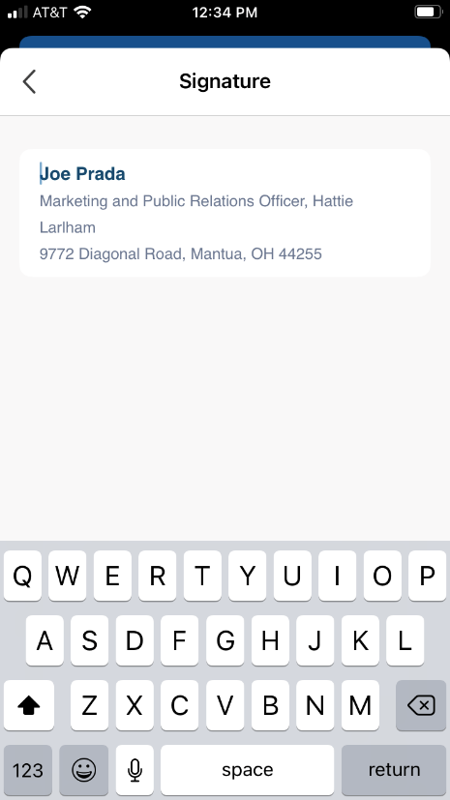

You’re finished setting up your signature on your Outlook App! When you select “New Email” your email draft should automatically generate this new signature. If you are not seeing the following (screen shot below), please contact I.T. Department. Note: When replying or forwarding an email from the Outlook App, it will not generate a signature due to Outlook App capabilities.

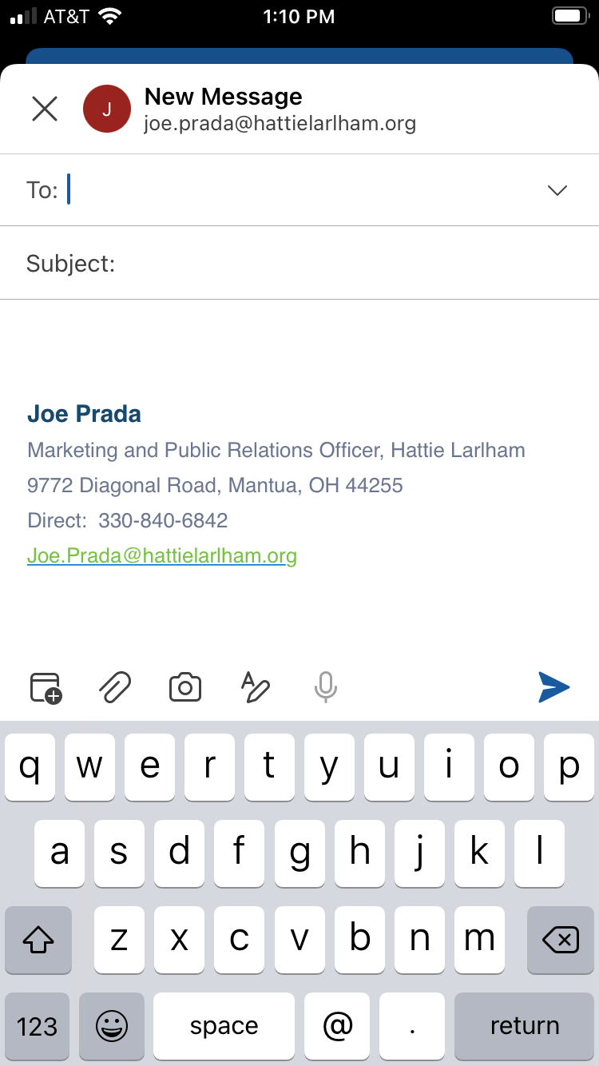

General Email Guidelines to Follow:
- Your email body text should be the default Outlook setting of “Calibri (Body)”, Font Size “11”, Color “Automatic” (black). Do not adjust your default font to any special colors or fonts. Do not add any type of background/backdrop imagery or texture to your emails. Emails should be sent with the standard white backdrop.

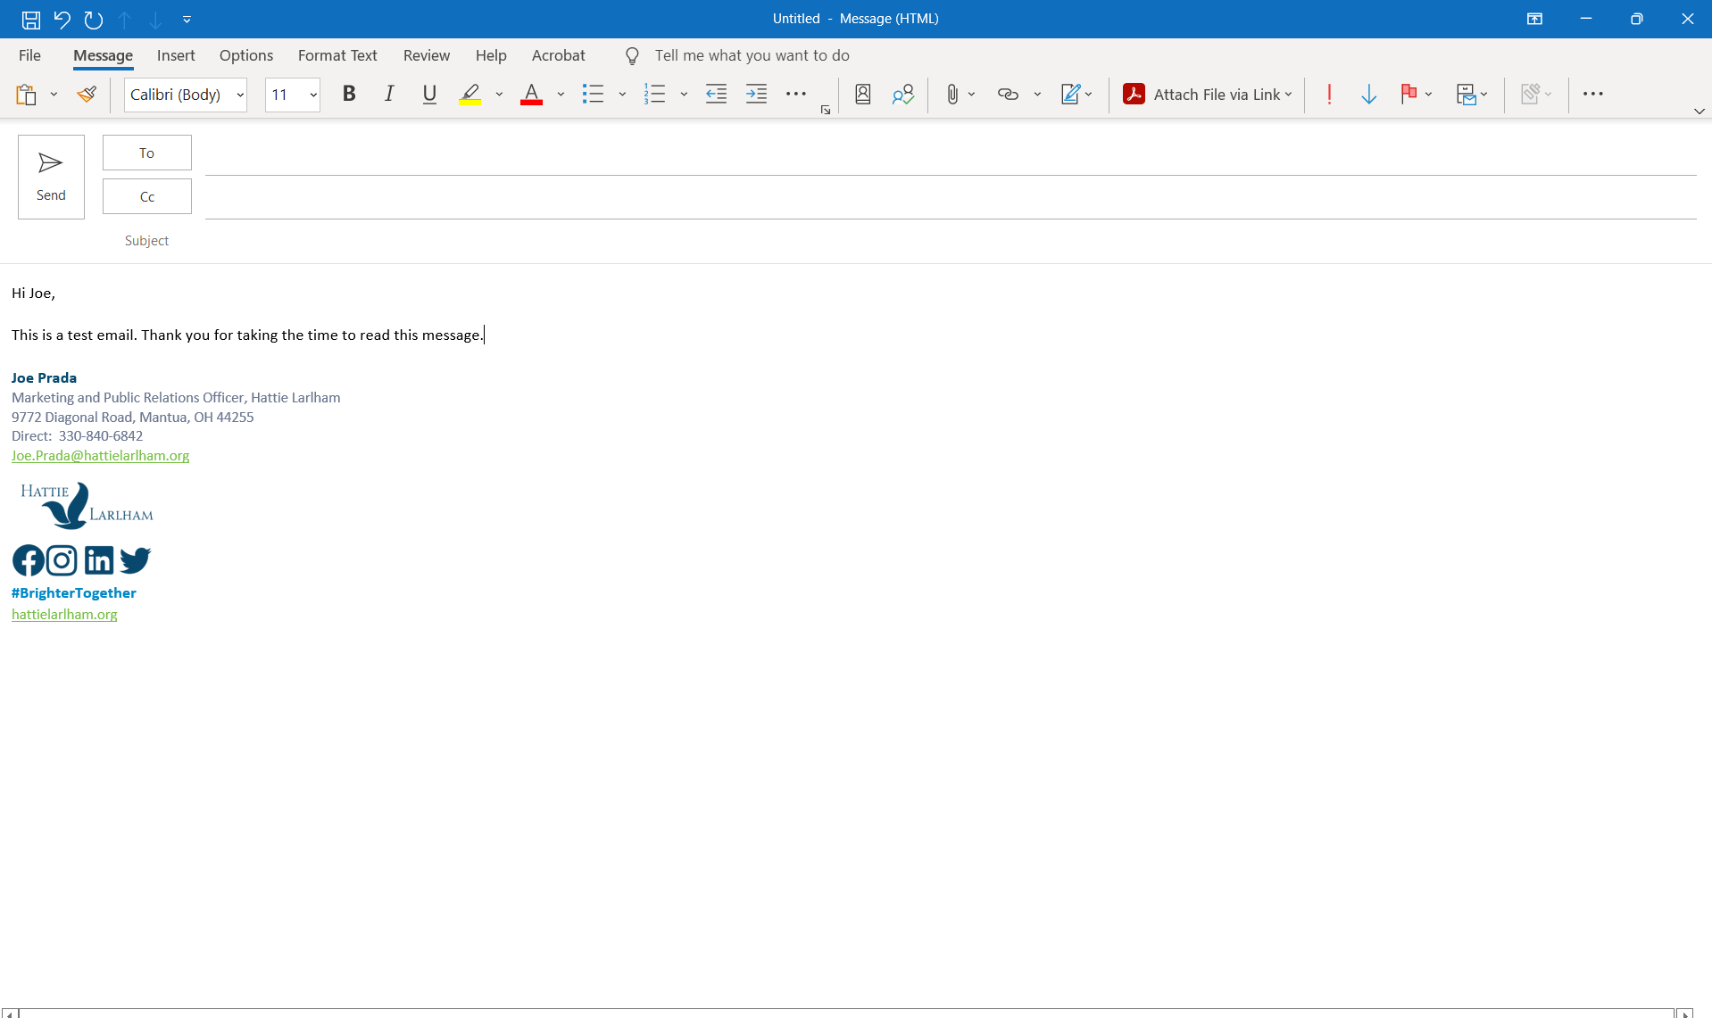

- Your Outlook Account Photo should remain the default Outlook setting of your initials with colored background or reflect a professional portrait-style photo of yourself. No other imagery should be used.
